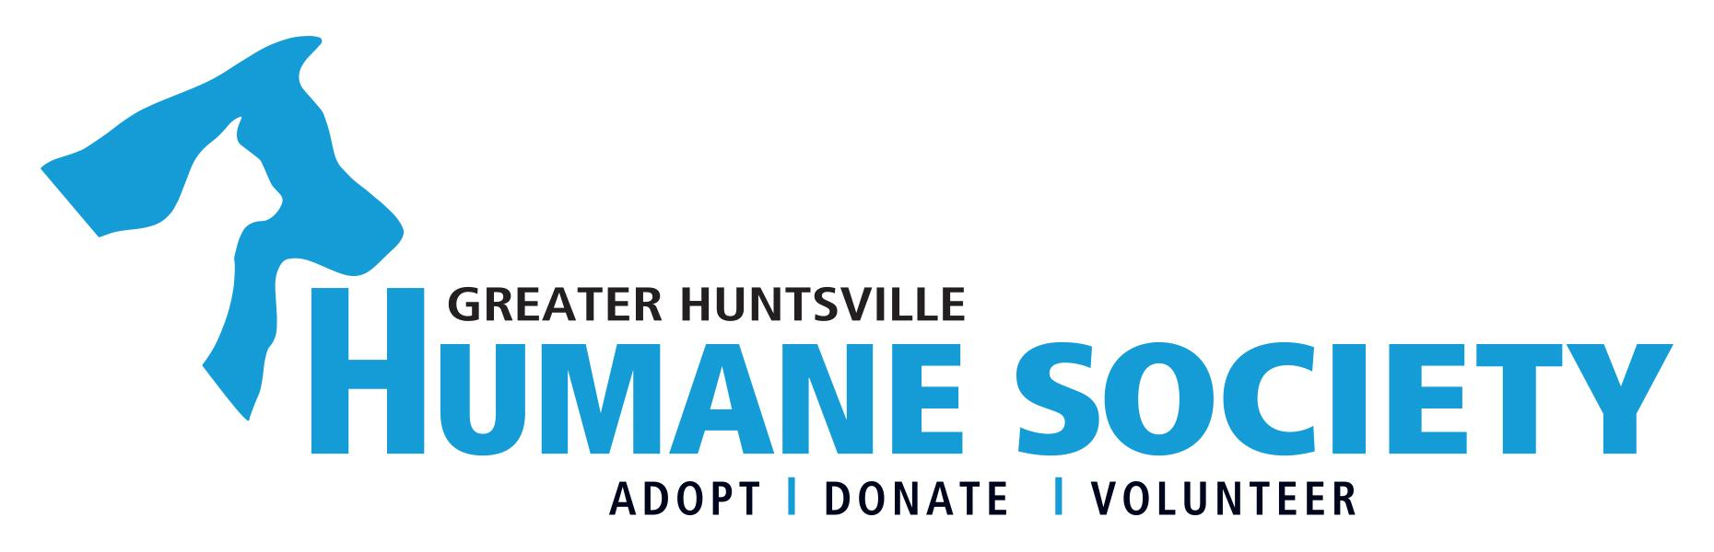

Parental Consent Form
We need your consent for your underage child to volunteer with us. Any volunteers under the age of 19 years old require a signed parental consent form. If you have any questions please feel free to call Marguerite Long, Volunteer & Community Outreach Coordinator at (256) 567-3790.

Name of Youth Volunteer:______________________________________________________________

Name Of Guardian:___________________________________________________________________

Relationship to Volunteer: ______________________________________________________________

Legal Release
I understand that they will be provided with orientation and training necessary for the safe and responsible performance of their duties and they will be expected to meet all the requirements of the position, including regular attendance and adherence to agency policies and procedures. I understand that they will not receive monetary compensation for the services contributed.

I agree that on behalf of myself, my heirs, personal representatives and executors; I release, discharge, indemnify and hold harmless the Greater Huntsville Humane Society, its agents, employees, directors and board of director from any and all claims, causes of action, or damage of any nature in connection with the same, based on damages or injuries which may be incurred or sustained in any way connected with volunteer services performed for The Greater Huntsville Humane Society including but not limited to animal bites, accidents, or injuries.

Signature: ________________________________________________________________________

Printed Name: _____________________________________________________________________

Date: ____________________________________________________________________________

MEDIA AUTHORIZATION AND RELEASE
(If withholding consent, please do not sign)

In connection with the Release of Liability contemporaneously signed herewith, I hereby give my permission and full release for any photo or video of my Child taken by the Greater Huntsville Humane Society, its officers, agents, directors, employees, sponsors, volunteers, affiliates, and/or successor and assigns thereof (collectively, “GHHS”) during the Lucky Dog program to be used for publicity and marketing purposes, including but not limited to GHHS’s website, literature, posters, television, social media and newspaper.

PARENT/LEGAL GUARDIAN:____________________________________________________________________

Printed Name: ________________________________________________________________________________

Date: _______________________________________________________________________________________

